[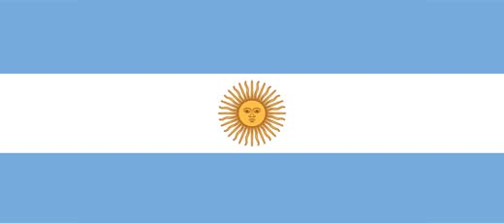](http://www.google.com/url?sa=i&rct=j&q=&esrc=s&source=images&cd=&cad=rja&uact=8&ved=0CAcQjRxqFQoTCIykj4u9hsgCFco2PgodZuAGJg&url=http://www.donquijote.org/culture/argentina/history/argentina-flag&bvm=bv.103073922,d.dmo&psig=AFQjCNFfFn-YnJE4RYUwiRqfeHwzKhhSVw&ust=1442868207317049)

[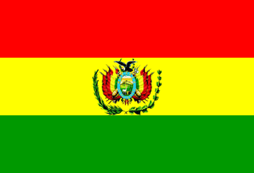](http://www.google.com/url?sa=i&rct=j&q=&esrc=s&source=images&cd=&cad=rja&uact=8&ved=0CAcQjRxqFQoTCPa8pPe7hsgCFYZbPgodYh4Oyg&url=http://www.crwflags.com/fotw/flags/bo%5e.html&psig=AFQjCNHk0-yAhG09jvbE_kaC-hL5Ze1K4w&ust=1442867899250737)

[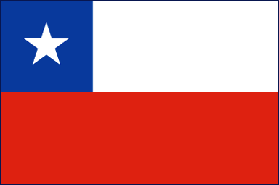](http://www.google.com/url?sa=i&rct=j&q=&esrc=s&source=images&cd=&cad=rja&uact=8&ved=0CAcQjRxqFQoTCOj0r8K9hsgCFcpWPgodH2wKsA&url=http://www.mapsofworld.com/flags/chile-flag.html&bvm=bv.103073922,d.dmo&psig=AFQjCNGnqJiIzwJMn6TBLo5WzRcQHG5AOw&ust=1442868322096381)

[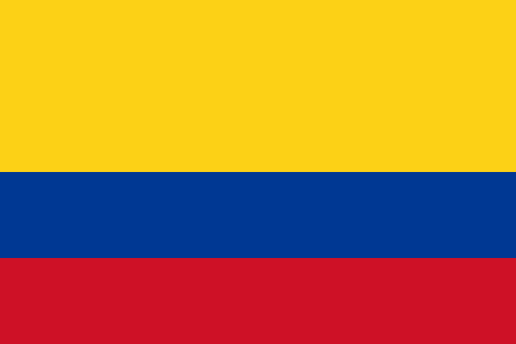](https://www.google.com/url?sa=i&rct=j&q=&esrc=s&source=images&cd=&cad=rja&uact=8&ved=0CAcQjRxqFQoTCI-x_IK8hsgCFQJcPgodGHULTg&url=https://en.wikipedia.org/wiki/Flag_of_Colombia&bvm=bv.103073922,d.dmo&psig=AFQjCNG8E_3nPwRIrrzlI_7cAq_RF7MgNQ&ust=1442867923753235)

País:

Capital:

Apuntes:

País:

Capital:

Apuntes:

País:

Capital:

Apuntes:

País:

Capital:

Apuntes:

[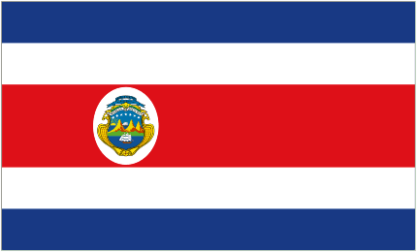](http://www.google.com/url?sa=i&rct=j&q=&esrc=s&source=images&cd=&cad=rja&uact=8&ved=0CAcQjRxqFQoTCIqEyp28hsgCFcgbPgodGHELxw&url=http://www.flags.net/CORC.htm&bvm=bv.103073922,d.dmo&psig=AFQjCNGVBOa3LC8E_cQcSbYDTG2Omsc-Nw&ust=1442867976608751)

[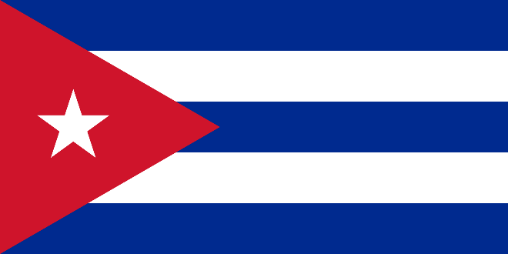](https://www.google.com/url?sa=i&rct=j&q=&esrc=s&source=images&cd=&cad=rja&uact=8&ved=0CAcQjRxqFQoTCLGwo428hsgCFYw6Pgod_5wAzA&url=https://en.wikipedia.org/wiki/Flag_of_Cuba&bvm=bv.103073922,d.dmo&psig=AFQjCNEVB3HvfIYrqSRaz7GWfvUtRsCrsg&ust=1442867946162279)

[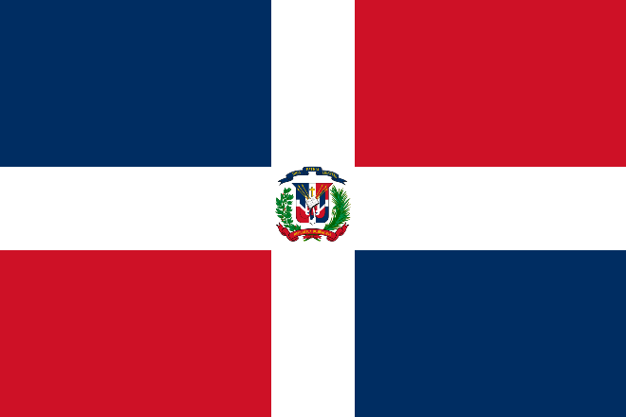](https://www.google.com/url?sa=i&rct=j&q=&esrc=s&source=images&cd=&cad=rja&uact=8&ved=0CAcQjRxqFQoTCJL-2IO-hsgCFQkyPgodVBYJOA&url=https://en.wikipedia.org/wiki/Flag_of_the_Dominican_Republic&bvm=bv.103073922,d.dmo&psig=AFQjCNFmULju5LE5GFAGallM8gD4Op-GnQ&ust=1442868462252067)

[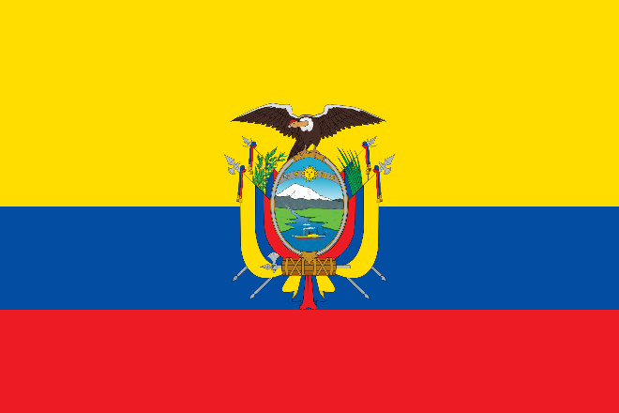](https://www.google.com/url?sa=i&rct=j&q=&esrc=s&source=images&cd=&cad=rja&uact=8&ved=0CAcQjRxqFQoTCJGQ6te8hsgCFQhoPgodJqoMsA&url=https://en.wikipedia.org/wiki/Flag_of_Ecuador&bvm=bv.103073922,d.dmo&psig=AFQjCNEP-HNG7Yg5sEUv2cxaGCEMGBUtZQ&ust=1442868102139323)

País:

Capital:

Apuntes:

País:

Capital:

Apuntes:

País:

Capital:

Apuntes:

País:

Capital:

Apuntes:

[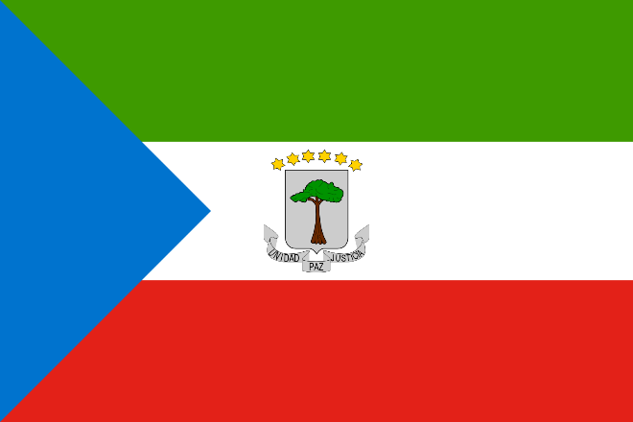](http://www.google.com/url?sa=i&rct=j&q=&esrc=s&source=images&cd=&cad=rja&uact=8&ved=0CAcQjRxqFQoTCJjS_6q-hsgCFQt4Pgod6vsMJA&url=http://flagpedia.net/equatorial-guinea&bvm=bv.103073922,d.dmo&psig=AFQjCNHPly9pS87QfA0rdrZBn9sLsDbhSg&ust=1442868544896597)

[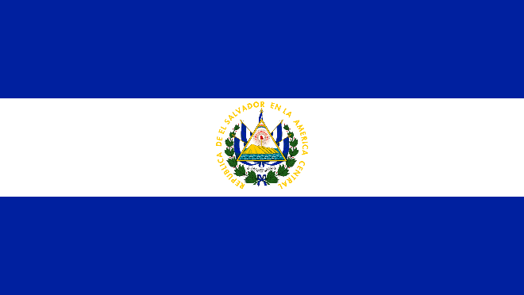](http://www.google.com/url?sa=i&rct=j&q=&esrc=s&source=images&cd=&cad=rja&uact=8&ved=0CAcQjRxqFQoTCOS93cG-hsgCFUNYPgodPZgOwQ&url=http://flagpedia.net/el-salvador&bvm=bv.103073922,d.dmo&psig=AFQjCNGGy1p27XivOupJ0AXQZX5Q8Sd5kQ&ust=1442868591608150)

[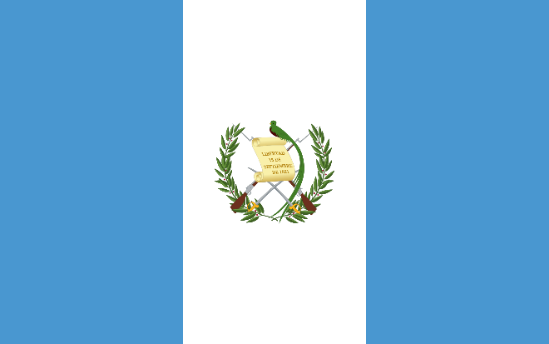](https://www.google.com/url?sa=i&rct=j&q=&esrc=s&source=images&cd=&cad=rja&uact=8&ved=0CAcQjRxqFQoTCJXSvOm-hsgCFYpwPgodJtoH4Q&url=https://en.wikipedia.org/wiki/Flag_of_Guatemala&bvm=bv.103073922,d.dmo&psig=AFQjCNEmjA4UQ7fyuQB-8qknkUSP_k6soA&ust=1442868675521384)

[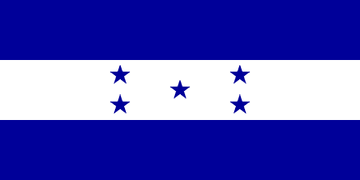](http://www.google.com/url?sa=i&rct=j&q=&esrc=s&source=images&cd=&cad=rja&uact=8&ved=0CAcQjRxqFQoTCPKSh4W_hsgCFYE7PgodW3gKkg&url=http://www.crwflags.com/fotw/flags/hn.html&bvm=bv.103073922,d.dmo&psig=AFQjCNGXDA3dOjhQ3ogxCsycuVbxLRSYpg&ust=1442868705087821)

País:

Capital:

Apuntes:

País:

Capital:

Apuntes:

País:

Capital:

Apuntes:

País:

Capital:

Apuntes:

[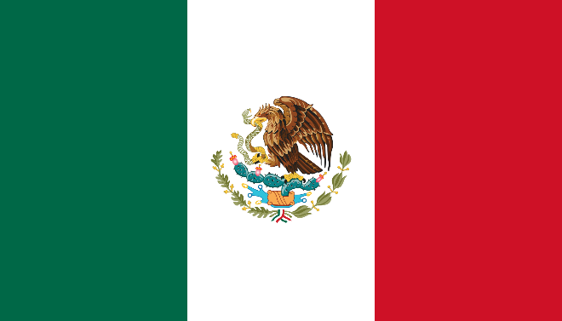](https://www.google.com/url?sa=i&rct=j&q=&esrc=s&source=images&cd=&cad=rja&uact=8&ved=0CAcQjRxqFQoTCLLlp5W_hsgCFQx1PgodZgoCKw&url=https://en.wikipedia.org/wiki/Flag_of_Mexico&bvm=bv.103073922,d.dmo&psig=AFQjCNFbkH5ytqGrGM7JYluF2tNde7bKfA&ust=1442868766744440)

[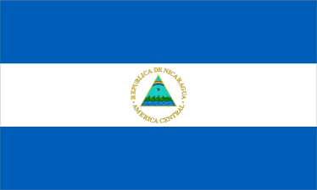](http://www.google.com/url?sa=i&rct=j&q=&esrc=s&source=images&cd=&cad=rja&uact=8&ved=0CAcQjRxqFQoTCOaqtbG_hsgCFQk3Pgod3IcJQQ&url=http://www.flags-by-swi.com/nicaragua_flag.html&bvm=bv.103073922,d.dmo&psig=AFQjCNHmyupNhCJMAsMfPhDz8gc3PIz0Tg&ust=1442868824389726)

[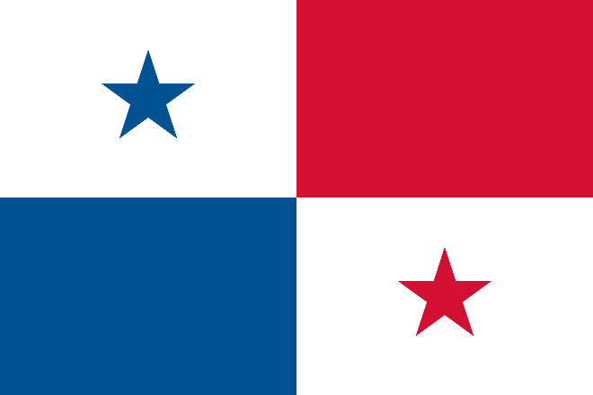](https://www.google.com/url?sa=i&rct=j&q=&esrc=s&source=images&cd=&cad=rja&uact=8&ved=0CAcQjRxqFQoTCNGm3L2_hsgCFQILPgodhT8AmQ&url=https://en.wikipedia.org/wiki/Flag_of_Panama&bvm=bv.103073922,d.dmo&psig=AFQjCNGBC54SlyDBUELXPAR3LknxrGfCdg&ust=1442868851191400)

[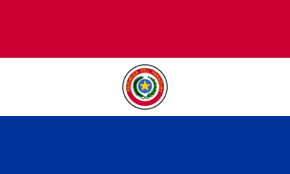](http://www.google.com/url?sa=i&rct=j&q=&esrc=s&source=images&cd=&cad=rja&uact=8&ved=0CAcQjRxqFQoTCJD23ci_hsgCFQJoPgodIC4DuQ&url=http://www.worldatlas.com/webimage/countrys/samerica/paraguay/pyflags.htm&bvm=bv.103073922,d.dmo&psig=AFQjCNGt5wQYDDjY3-LoUHqvnTa5wZ88CQ&ust=1442868874008058)

País:

Capital:

Apuntes:

País:

Capital:

Apuntes:

País:

Capital:

Apuntes:

País:

Capital:

Apuntes:

[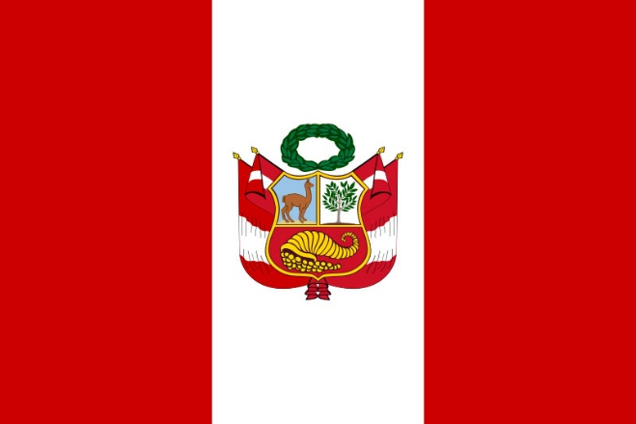](http://www.google.com/url?sa=i&rct=j&q=&esrc=s&source=images&cd=&cad=rja&uact=8&ved=0CAcQjRxqFQoTCOmIs9S_hsgCFQkyPgodVBYJOA&url=http://www.limaeasy.com/peru-info/important-facts-and-figures-about-peru/peruvian-national-state-war-flag&bvm=bv.103073922,d.dmo&psig=AFQjCNHk2lL-t4KCvrLpF1MNqH8prFZhFg&ust=1442868900254889)

[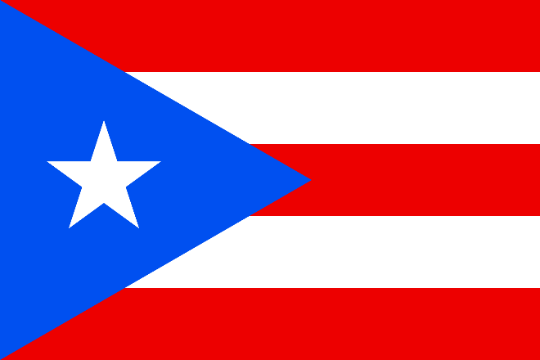](https://en.wikipedia.org/wiki/Flag_of_Puerto_Rico)

[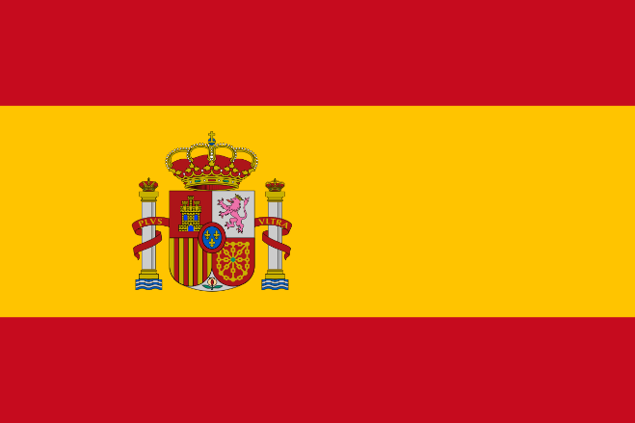](https://www.google.com/url?sa=i&rct=j&q=&esrc=s&source=images&cd=&cad=rja&uact=8&ved=0CAcQjRxqFQoTCISpgva_hsgCFYQ6Pgodi8gKZw&url=https://en.wikipedia.org/wiki/Flag_of_Spain&bvm=bv.103073922,d.dmo&psig=AFQjCNHRdjauBJSVc2xdPMLjICSOExIulw&ust=1442868968593714)

País:

Capital:

Apuntes:

País:

Capital:

Apuntes:

País:

Capital:

Apuntes:

[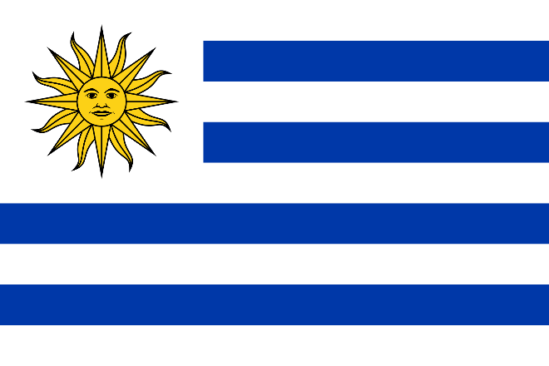](https://www.google.com/url?sa=i&rct=j&q=&esrc=s&source=images&cd=&cad=rja&uact=8&ved=0CAcQjRxqFQoTCKKmuoHAhsgCFYLzPgod6OgCrA&url=https://en.wikipedia.org/wiki/Flag_of_Uruguay&bvm=bv.103073922,d.dmo&psig=AFQjCNH0_dDPuQF7H1-Pdq0KQLKv_xe3UA&ust=1442868993641586)

[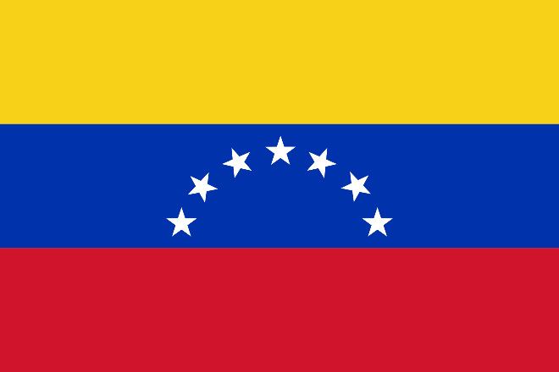](https://www.google.com/url?sa=i&rct=j&q=&esrc=s&source=images&cd=&cad=rja&uact=8&ved=0CAcQjRxqFQoTCKff9JHAhsgCFcIaPgod4sQNjA&url=https://en.wikipedia.org/wiki/Flag_of_Venezuela&bvm=bv.103073922,d.dmo&psig=AFQjCNHoUmtPqKTBmXrWzTrstgfMnhTO_g&ust=1442869028445068)

País:

Capital:

Apuntes:

País:

Capital:

Apuntes:

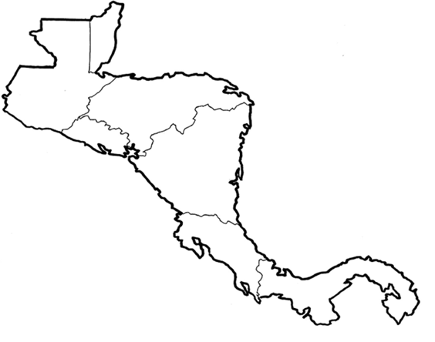

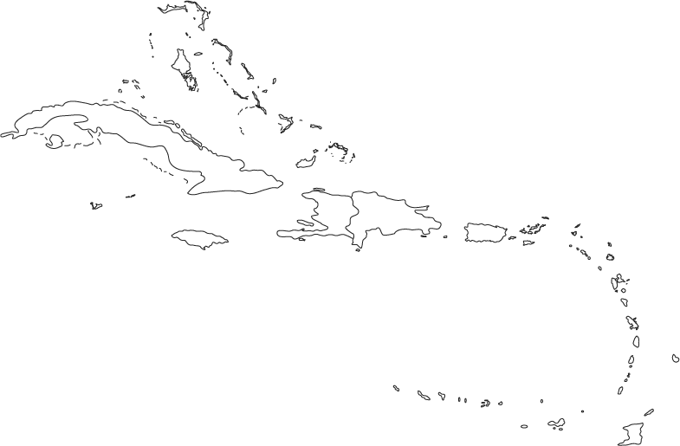

[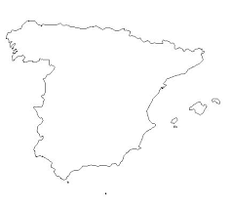](https://www.google.com/imgres?imgurl=http://0.tqn.com/d/geography/1/0/7/I/spain.jpg&imgrefurl=http://geography.about.com/library/blank/blxspain.htm&h=387&w=434&tbnid=JuoO_j9_v8mpoM:&docid=konlCDvJ-oy3xM&ei=PvT_VcWWNNemyASIp7rIBQ&tbm=isch&ved=0CCwQMygQMBBqFQoTCMWtkOWMiMgCFVcTkgodiJMOWQ)[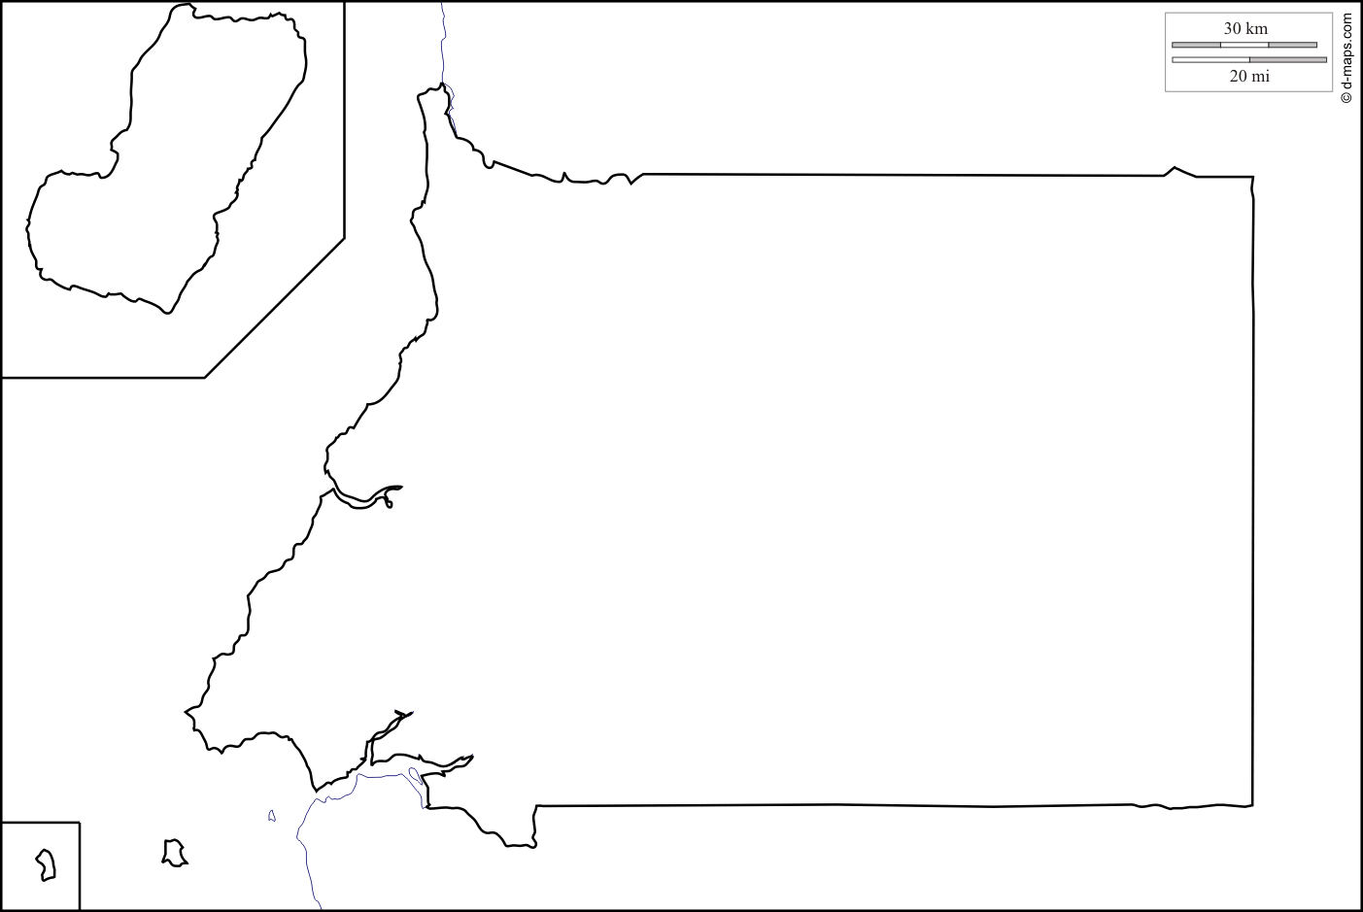](http://www.google.com/url?sa=i&rct=j&q=&esrc=s&source=images&cd=&cad=rja&uact=8&ved=0CAcQjRxqFQoTCN7ihouNiMgCFUIXkgodIJ0Icw&url=http://d-maps.com/carte.php?num_car%3D1011%26lang%3Den&bvm=bv.103073922,d.aWw&psig=AFQjCNFA6pXj2eSG6PQAMhKYlIne2cKljg&ust=1442924030161587)

[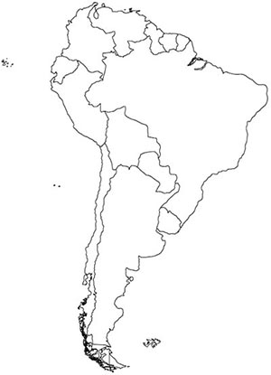](http://www.google.com/url?sa=i&rct=j&q=&esrc=s&source=images&cd=&cad=rja&uact=8&ved=0CAcQjRxqFQoTCIutn62MiMgCFVALkgodJe4HcA&url=http://www.thomas.k12.ga.us/olc/folder.aspx?id%3D25908%26c%3D8191%26s%3D484&psig=AFQjCNGk7k_23oqBc6r9ZWnbvp8uVSscDA&ust=1442923703741096)